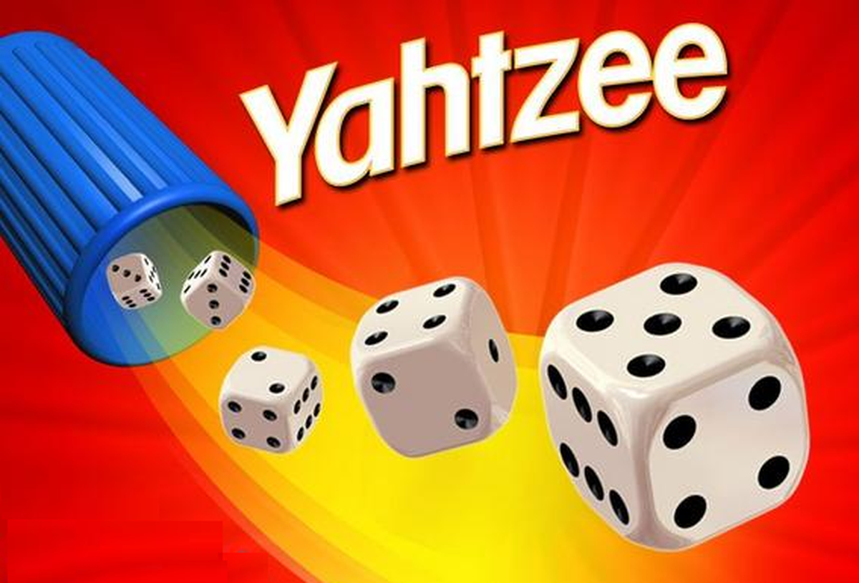

Yahtzee AI

Statement of work

Rui Tang, Sue Wang | Capstone Term I

# Abstract

## This article focuses on the Yahtzee game. During the teamwork, we will create two to three models to play games and compare these advantages and disadvantages.

## Introduction of Yahtzee

* **Yahtzee** is a [dice game](https://en.wikipedia.org/wiki/Dice_game) made by [Milton Bradley](https://en.wikipedia.org/wiki/Milton_Bradley_Company) (now owned by [Hasbro](https://en.wikipedia.org/wiki/Hasbro)), which was first marketed as Yatzie by the National Association Service of [Toledo, Ohio](https://en.wikipedia.org/wiki/Toledo,_Ohio), in the early 1940s. It was marketed under the name of Yahtzee by game entrepreneur [Edwin S. Lowe](https://en.wikipedia.org/wiki/Edwin_S._Lowe) in 1956. The game is a development of earlier dice games such as [Poker Dice](https://en.wikipedia.org/wiki/Poker_Dice), [Yacht](https://en.wikipedia.org/wiki/Yacht_(dice_game)) and [Generala](https://en.wikipedia.org/wiki/Generala" \o "Generala). It is also similar to [Yatzy](https://en.wikipedia.org/wiki/Yatzy), which is popular in [Scandinavia](https://en.wikipedia.org/wiki/Scandinavia).
* The objective of the game is to score points by rolling five [dice](https://en.wikipedia.org/wiki/Dice) to make certain combinations. The dice can be rolled up to three times in a turn to try to make various scoring combinations and dice must remain in the box. A game consists of thirteen rounds. After each round the player chooses which scoring category is to be used for that round. Once a category has been used in the game, it cannot be used again. The scoring categories have varying point values, some of which are fixed values and others for which the score depends on the value of the dice. A Yahtzee is five-of-a-kind and scores 50 points, the highest of any category. The winner is the player who scores the most points.
* Yahtzee was marketed by the E.S. Lowe Company from 1956 until 1973. In 1973, the [Milton Bradley Company](https://en.wikipedia.org/wiki/Milton_Bradley_Company) purchased the E.S. Lowe Company and assumed the rights to produce and sell Yahtzee. During Lowe's ownership over 40 million Yahtzee games were sold worldwide. According to current owner [Hasbro](https://en.wikipedia.org/wiki/Hasbro), 50 million Yahtzee games are sold each year. A classic edition is currently being marketed by [Winning Moves](https://en.wikipedia.org/wiki/Winning_Moves).[1]

## Rules

A classic Yahtzee game has 13 turns and 13 types of scores plus a bonus score. Each type of score must and only be selected once. In each turn, players can roll five dices and reroll up to two times. When rerolling, the player can keep any of dices at that moment and reroll the others. If players want to write the score onto the score board (or the reroll times used out), they should select one of the score type and calculate the corresponding score then record it. If the numerical score is higher than 63, a 35-score bonus will be earned.

The detail rules show following:

|  |  |  |  |
| --- | --- | --- | --- |
| **Categories** | **Descriptions** | **Scores** | **Examples** |
| **Aces** | Any combination | The sum of dice with the number 1 | scores 3 |
| **Twos** | Any combination | The sum of dice with the number 2 | scores 6 |
| **Threes** | Any combination | The sum of dice with the number 3 | scores 12 |
| **Fours** | Any combination | The sum of dice with the number 4 | scores 8 |
| **Fives** | Any combination | The sum of dice with the number 5 | scores 5 |
| **Sixes** | Any combination | The sum of dice with the number 6 | scores 18 |
| **Bonus** | If the sum of all numerical scores greater than or equals 63 | 35 |  |
| **Three Of A Kind** | At least three dice the same | Sum of all dice | scores 17 |
| **Four Of A Kind** | At least four dice the same | Sum of all dice | scores 24 |
| **Full House** | Three of one number and two of another | 25 | scores 25 |
| **Small Straight** | Four sequential dice (1-2-3-4, 2-3-4-5, or 3-4-5-6) | 30 | scores 30 |
| **Large Straight** | Five sequential dice (1-2-3-4-5 or 2-3-4-5-6) | 40 | scores 40 |
| **Yahtzee** | All five dice the same | 50 | scores 50 |
| **Chance** | Any combination | Sum of all dice | scores 13 |

## Objectives

In 2016, AlphaGo defeated the world Go champion Lee Sedol and shocked the whole world. But the more far-reaching significances lies in it shows the possibility that AI can not only just do simple works, but also can solve complex problems like games.

Inspired by AlphaGo and based on our personal interests, our team decided to train a game AI. In the first step, we are focusing on how to get a higher score in Yahtzee Game. Then, we hope we can optimize these models and generalize these models into other types of games.

## Data Needed

In this project, our models will be self-driven. In another word, like most reinforcement learning projects, there will be an environment and the model can extract information from the environment and self-iterate to an optimal solution.

## ML Models

### **Search**

The Search algorithm is a basic algorithm that can predict each step precisely. The core formula is

$$E=max⁡(\left\{E\left(next\right)+score in current step\right|next in all posible moves\}$$

And the end state:

$$E\left(end\right)=0 where game cannot have next moves$$

This model’s advantage is precise. However, it may cost too much space and too detailed.

### **Reinforcement learning based on Q-Learning**

On the previous algorithm we calculate all the details including the expected value on each step manually. To generalize models, we expect an algorithm that the model itself can calculate each step by iteration. In Q-Learning, each step can feedback its previous step. By proof we know the Reward Matrix will converge to the optimal solution.

Q-learning may spend more time to converge and use same memory space as Searching, but we expect we can use GPU and parallel to increase computing speed.

### **Neural Network (if possible)**

For now, we have no idea about neural network. We expect it can offer a very tiny model.

## schedule

### **Step 1: Sep 7 – Oct 4 (current)**

We create a python Yahtzee simulator and based on it implement the searching algorithm. However, the difficulty is we cannot get results in ideal time. One of these reasons is Python is an interpreted language, so it is too slow. Another reason is in python we cannot access memory directly so that we cannot do more optimization.

### **Step 2: Oct 5 - Oct22**

Implement the Search algorithm in C++ and optimize it to make sure we can get results in acceptable time.

### **Step 3: Oct 23 – Nov 15**

Implement Q-Learning model or Sarsa Model and compare them.

### **Step 4: Nov 16 – Dec 10**

Write the report to conclude the whole capstone term I.

Try to implement neural network if possible.

1. Wikipedia <https://en.wikipedia.org/wiki/Yahtzee>